# **ME202 : Machine Drawing Project**

|  |  |  |
| --- | --- | --- |
| Name – Priyanshu Gupta | Entry No. 2022MEB1330 | Section B(Friday) |

Title : CAD Modeling of Arbor Press in Solidworks.

Objective:

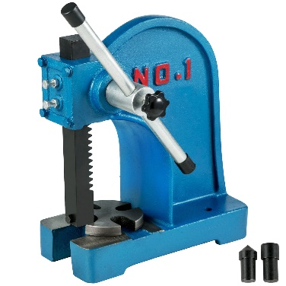The primary objective of this project is to create a detailed and accurate 3D CAD model of an Arbor Press using SolidWorks software. This model will serve as a comprehensive visual representation of the Arbor Press, aiding in design evaluation, product documentation. The project aims to achieve a high level of detail in the CAD model, ensuring that it accurately represents the components and mechanisms of an Arbor Press. . The creation of technical documentation, including 2D drawings, exploded views, and Bill of Materials (BOM), is another crucial aspect of the project to provide clear and comprehensive information. Lastly, the project will focus on enhancing the model's visualization by applying realistic materials, textures, and appearances, making it visually appealing and informative. Overall, this CAD modeling project seeks to improve our understanding of Arbor Press mechanics, enhance our SolidWorks modeling skills, and provide a valuable tool for design and analysis purposes.

Description :

An Arbor Press is a mechanical device designed for performing various pressing, stamping, and forming tasks in industrial and workshop settings. This compact and manually operated tool consists of a lever, a ratcheting mechanism, and a ram. Arbor presses come in different sizes and capacities, offering versatility in their applications.

**Base:**

The base is the sturdy and often heavy foundation of the arbor press. It provides stability and support for the entire press.

**Lever Arm:**

The lever arm is the long handle of the press, which the operator uses to apply force. When the lever is pushed or pulled, it translates the operator's input force into downward motion of the ram.

**Ram:**

The ram is the uppermost part of the press that directly contacts the workpiece. It can be raised or lowered to apply pressure to the material. The ram may have a flat, concave, or other specialized surface depending on the specific task.

**Arbor/Spindle:**

The arbor or spindle is a vertical shaft that the ram is mounted on. It can be rotated to control the vertical movement of the ram. This allows for precise adjustment of the applied force.

**Ratcheting Mechanism:**

The ratcheting mechanism is often located near the top of the press and is used to control the lowering and raising of the ram. It provides a convenient way to lock the ram in position at different heights, ensuring consistent pressure.

**Base Plate or Worktable:**

Some arbor presses have a base plate or worktable on the base. This provides a flat surface on which the workpiece can be positioned and secured for the pressing operation.

**Adjustment Handles or Knobs:**

These controls, often found near the spindle, allow for fine-tuning the position of the arbor or spindle, enabling precise adjustments to the applied force.

These devices are widely used in tool and die making, machine shops, assembly lines, and manufacturing environments where accuracy and precision are paramount. Arbor presses can accommodate a variety of tooling attachments and accessories, making them adaptable to a range of applications. Their mechanical simplicity and ease of operation make them a practical choice for tasks that demand controlled force and accuracy, and they are an essential tool for many manufacturing and repair processes.

Conclusion :

Upon successful completion of this project, we will have a detailed and accurate 3D CAD model of an Arbor Press, which can serve as a valuable tool for design, analysis, and documentation purposes. This project is expected to enhance our understanding of Arbor Press mechanisms and improve our CAD modelling skills using SolidWorks